Newark Community Art Club with Elaine Winter
Session 14: Self-Portrait

Materials needed:
White paper x 2 pieces
A pencil
A pen (any kind will do, can be a normal biro or a felt-tip, whatever you have to hand)
A piece of string or ribbon
A mirror
A watch or phone with a stopwatch that you can time yourself with

Introduction: Self-portraits have been central to many artists for their careers. Often it is the case that they have used themselves as a subject because they could not afford to pay for a model. Sometimes however it is simply the case that our own image is with us and easy to work from, as long as we can locate a mirror that is. This session will take you through a set of quick drawing exercises to help you improve your hand eye co-ordination and at the same time you can have fun making different kinds of portraits of yourself.

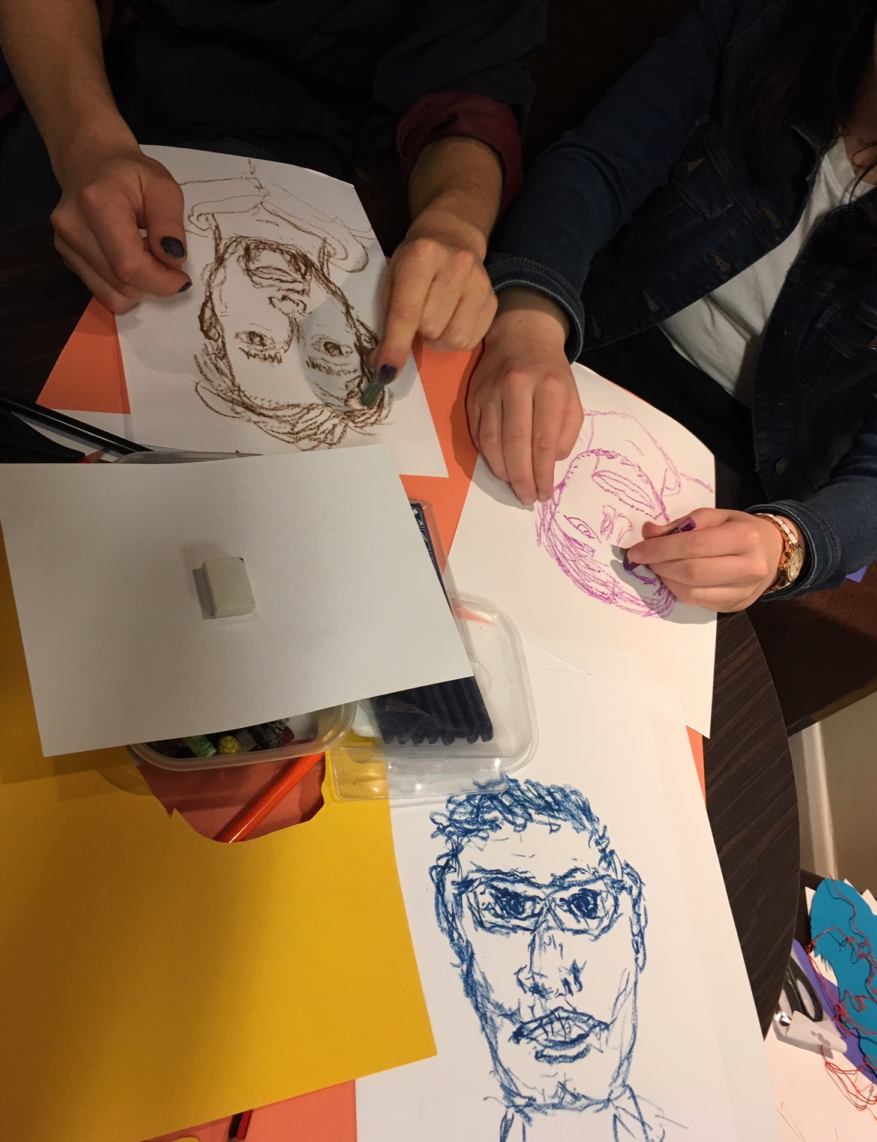
Activity 1: Set yourself up in a position to draw yourself. Take a piece of paper and divide it into 4. In the first of the 4 areas do a very quick pencil self-portrait. Set your timer for 5 minutes. These drawings are all meant to be very quick and not perfect so do not use a rubber and don’t worry too much!

Activity 2: In the second area do another 5 minute self-portrait but this time with a pen. Using a pen will give you a different kind of line and will improve your confidence, there’s no going back with drawing with a pen.

Activity 3: In the third of the 4 areas do another self-portrait but this time do it as a continuous line and using a pen. By continuous line I mean do not take your pen off the paper and act as if it is a magnet to the paper but one you can move around. This will give you a really interesting and strong drawing. Remember you can go backwards and forwards but you can’t take your pen off the paper. Again set the timer for 5 minutes.

Activity 4: Take the piece of string and in the fourth area try to make a simplified version of the continuous line drawing but using the string as your ‘drawing line’. It isn’t easy as the string will try to move around but have a go and remember it is just a fun way to do a portrait so it doesn’t have to be perfect. Again just take 5 minutes to do this portrait.

Activity 5: Now you have done all these quick warm up activities to get your hand-eye co-ordination tuned in, take your other piece of paper and use it for a bigger self-portrait. You can use pencil or pen for this (depends on how confident you are feeling after doing the exercises!). Before you start to draw yourself spend a good 5 minutes just looking at yourself. This might sound odd but look at yourself in a new way. Look at how close or how far away features are from each other and pay special attention to what happens between the features e.g. what happens between the nose and the mouth, it is not just a gap! Often when we draw a face we focus on eyes, nose and mouth only but there is so much more to it so add as much detail as you can and spend as long as you would like to on this portrait. Try to be honest with your drawing and with yourself!

